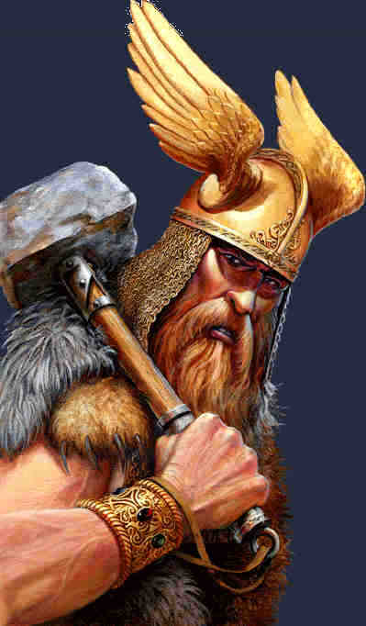

**Mighty Thor and The Magic Hammer**

**Chapter 1**

Thor, the God of Thunder, came running into the village. “I’ve lost my mighty hammer!” he shouted. Thor’s hammer was magic. It could kill an army with one blow! It could bring peace to the world!

Thor’s father, Odin, the King of the Gods cried, “We must get the hammer back!” Everyone looked for Thor’s hammer – but it was no where to be found.

Suddenly, a servant ran in. “The Frost Giant, Thrym has the hammer!”

“But Thrym is evil! He will never give it back. What

shall we do?” screamed Odin.

Thor roared, “I will find Thrym and kill him! I must have my hammer back.”

But Thrym was a very strong giant so Odin told Thor that he should not fight him. They wanted to find out why Thrym had Thor’s hammer. They sent Loki, the God of Mischief, to find Thrym.

**Chapter 2**

Loki found Thrym and said, “Thrym, Odin has sent me to ask you to give his hammer back.”

“Ha, ha, ha! I am not going to give it back!” shouted Thrym. “I want Freya, the Goddess of Love, to be my wife. Give me Freya and I will give Thor his hammer,” shouted Thrym.

When Loki got back he told Thor what Thrym wanted. Odin was angry. “Thrym wants our lovely Freya? Never!”

But Odin knew he had to do something, so he called for Freya. When Freya heard what Thrym wanted, she screamed,

“I’d rather die than marry him!”

Loki shouted out, “I have a plan! I have a plan! Thrym wants Freya – so we will give him what he wants!”

“How can we? She won’t go!” Odin said.

Loki said, “Freya won’t go. But Thor could dress up as her!”

“Who? Me? But I am a God! I can’t dress up like a girl!” he shouted.

However, he eventually gave in. Freya came and dressed Thor in a dress and a wig and gave him her special necklace. “Thrym will recognise the necklace,” said Freya. At last, Thor was ready.

**Chapter 3**

When they arrived, Thrym greeted them. ”Oh lovely Freya! I did not think you would come!”

“Well, here she is – now give us the hammer!” said Loki. But Thrym was not a fool. He wanted to talk to Freya first.

“Come, let me kiss you.” Thyrm whispered to Thor. Thor started to move away.

“No, no, not yet – wait ‘til you are married! First you must give us the hammer!” Loki shouted.

But Thrym couldn’t wait. He wanted to kiss Freya now. Thrym gave the mighty hammer to Thor.

“Now my sweet Freya, you must thank me with a kiss,” Thrym said sweetly.

Thor replied quickly, “I will . . . but not with a kiss . . . I AM THE MIGHTY THOR! YOU GAVE ME THE HAMMER AND I WILL GIVE IT STRAIGHT BACK!”

Thor hit Thrym on the head with his hammer with all his strength.

“Run!“ Yelled Loki to Thor.

Thor and Loki ran back to Odin. The hammer was back where it belonged. Thrym had a very sore head. And Thor never had to wear a dress again!

Reading Comprehension

Mighty Thor and the Magic Hammer

1. What was special about Thor’s magic hammer?
2. What was Thor’s first idea to get back his hammer?
3. Why did Thrym steal Thor’s hammer?
4. What did Freya say when she knew that Thrym wanted to marry her?
5. Why did Freya say it was important for Thor to wear her necklace?
6. What was the plan to get Thor’s hammer back?